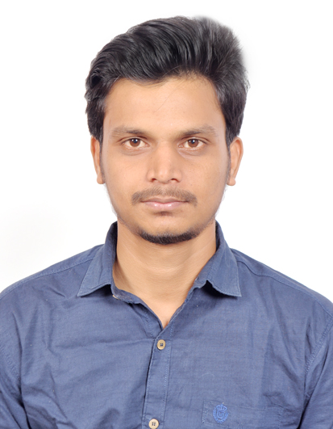
9604053432 8788214795
bargalumesh673@gmail.com
BARAGL UMESH UTTAM
CAREER OBJECTIVE
ACADEMIC PROJECT
TECHNICAL SKILLS
ACHIVEMENTS
EDUCATION QUALIFICATION
- I got NSS award for my hard work in youth for conversation of environment natural source.
- I played kho-kho at national level and also played kabaddi.

- Name : Creation of static Website for institute information purpose

- Institute Name : MIT College CS and IT Basmath.

GRADUATION : Completed Bachelor of Computer Application (B.C.A)(2018) From Swami Ramanand
Titrth Marathwada University Nanded (SRTMUN)
INTERMIDIAE : Completed +2Science(2012) From Cambridge college Basmath, .
MATRICULAION: Completed 10th (2010) Basweshwar high school, Nanded.

- Programming Languages: HTML, HTML5, CSS, BOOTSTRAP,JQUERY
- I am quite good in HTML,CSS,CSS3
- Application Software: MS-Office Word, Microsoft excel and Power Point.

- To work with an organization which provides contributory environment and also believes in proactive changes with the changing competitive environment where I can use my knowledge and talent.
- Seeking a chance to put to use my skills acquired as a student of B.C.A and practically apply it according to the requirements of the company which will give me a chance to learn and grow professionally and also give an opportunity to contribute towards the company through my knowledge and talent.

EXERIENCE

- Worked at Karvy Digikonnect as a Customer Care Executive for 1 year.

- Worked at Altruist Technology Pvt. Ltd., as Sales Executive for 1.4 years

PERSONAL PROFILE
STRENGTH
- NAME : Umesh Uttamrao Bargal

DATE OF BIRTH : 12th April 1995
- PERMANENT ADDRESS : At.post kamtha tq.Ardhapur Dist.nanded
- GENDER : Male
- NATIONALITY : Indian
- RELIGION : Hindu
- LANGUAGES KNOWN : English, Hindi, and Marathi.

DECLARATION
I hereby solemnly declare that information given above is true and complete to the best of my knowledge.

Place: Hyderabad
Date Signature

The ability to work in a team.
- Positive attitude.
- Faithful.
- Always ready to take responsibility.
- Interest to achieve set target in a stipulated time.
- Decision making capacity.

