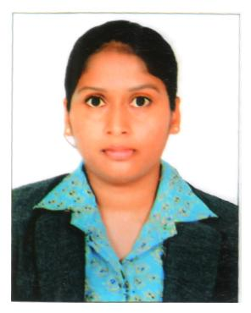
CURRICULUM VITAE
KYAMA.MOUNIkA
Mobile :9490229008,6304831475
EMail : kyamamouni002@gmail.com
ADRESS:H.NO-01,SREE MANIKANTA NILAYAM,PRASHANTI HILLS
MEERPET,HYDERABAD,RANGAREDDY DISTRICT,PINCODE:500097

Career Objective
I would like to be work in an organization which gives me professional growth as well as monetary growth.
Educational Qualification
- Completed B.A[HEP]from Kakatiya University
Khammam, Telangana State, with 80%.

- Completed Intermediate from Master Minds Junior College
Khammam, Telangana State,with 79%.

- Completed S.S.C from Board of Secondary Education
Khammam, Telangana State,with 85%.

Career oriented certification programmed
- Diploma in Ground Staff from Master Aviation Academy, Vijayawada
WORK EXPERIENCE
- Worked as a C.S.A (Customer Service Executive) in(Srilankan Airlines)SE AEROSPACE ONE PVT LTD., at ANNA INTERNATIONAL AIRPORT.., CHENNAI From 27NOV2012 TO 21FEB2015(2.3YEARS).
- worked as P.S.A(passenger service agent) for QATAR AIRWAYS (CAMBATA AVIATION PVTLIMITED) at ANNA INTERNATIONAL AIRPORTCHENNAI From15JUL2016 to 18DEC2016(05months).
- Worked as customer service officer(C.S.O]for INDIGO AIRLINES.from MARCH 2017 TO JULY2019
- Currently working as VOICE ASSOCIATE For US Telecalling for OPTIMUM IT HUB From 06MONTHS.

PROFESSIONAL EXPERIENCE
- Greeting and Assisting Airline customers in a polite and courteous manner.
- Ushering passengers to the aircraft.
- Proven ability in excess baggage, GD (General Declaration), Floor Walking, Arrivals, Departures, Checking and MHB (Mishandling Baggage).
- Escorting the passengers with special attention towards old and handicapped.
- Transfering US out bound calls successfully on given products,worked on many projects like SOLAR INSTALLATION.OBAMA HEALTH CARE.

TRAININGS DONE IN WORKING PERIOD ARE
- Mishandled Baggage MHB (WORLD TRACER)
- DCS Check-in training done for ALTEA SYSTEM(AMADEUS)
- AMADEUS RESERVATIONS &TICKETING
- DGR Training Category 9(Awareness on dangerous goods )
- EMD Electronic Mischellious Document (AMADEUS)
- Airport Emergency Exercise Training.
- US English listening skills,understanding.

SKILLS AND INTEREST
- Enjoy working with the public and meeting new people.
- Be a team member
- Good communication skills
HOBBIES
- Listing music
- Learning new languages
- Cooking

PERSONAL DETAILS
Name : KYAMA MOUNIKA
Fathers Name : KYAMA NAGARJUNA [Late]
Date of Birth : 02.Feb.1994
Marital Status : MARRIED
Gender : FEMALE
Height : 156 c.m
Weight : 55 kgs
Vision : NORMAL
Religion : HINDU
Nationality : INDIAN
Passport : YES (K4734760)
Languages Known : TELUGU (Mother Tongue), HINDI,
ENGLISH & TAMIL

DECLARATION

I hereby declare that all the details furnished the above are true to the best of my knowledge.

Date :
Place : KYAMA.MOUNIkA

